Design Document

WebbiSkools Quiz Manager

Aimee Craig

2019

Contents

Background Information 2

Business Requirements 2

Users and Permissions 2

Quizzes 2

Viewing and Editing 2

Assumptions 3

User Interface 3

Style Guide 3

Sitemap 3

Wireframes 4

Architectural Design 9

Database 9

Classes 10

User Interactions 10

Sequence Diagram 10

Use Case 11

User Stories 12

# Background Information

WebbiSkools Ltd is a software company that provides on-line educational solutions for educational establishments and training providers. I have been tasked with designing, building, and testing a database-driven website to manage quizzes, each consisting of a set of multiple-choice questions and their associated answers. The website’s capabilities will only be accessible to known users. Users with full permissions will be able to view and edit the questions and answers; users with lesser permissions will be able to view them but not edit them; users with minimal permissions will only be able to see the questions.

# Business Requirements

## Users and Permissions

* The set of users with their usernames, passwords and permissions should be pre-configured. This may be done by manually inputting data into the database, through a separate user-config file (e.g. an XML, JSON or CSV file), or any other mechanism of your choice.
* Stored passwords should be hashed for security, using a suitable hash algorithm.
* Permission levels should be one of {Edit, View, Restricted}, where Edit means the ability to add, delete and change questions and answers, View means the ability to view questions and answers, and Restricted means the ability to view questions only.
* Only known users can log in to the website. Once logged in, a user can only carry out the actions allowed by their permission level.
* The website will need to maintain the user’s session state while the user is logged in.
* You may assume that the number of users with edit permissions is small, and the probability of more than one user attempting to edit a quiz simultaneously is negligible.
* A user can logout, which will take them back to the login page.

## Quizzes

* A quiz has a title and a numbered sequence of questions.
* Each question is formulated as a text string, e.g. “What is the approximate population of London?”
* Each question is associated with a set of between 3 and 5 answers. Each answer is a text string, shown in the user interface indexed by an uppercase character (‘A’, ‘B’, ‘C’ etc). For example, the answers to the above question might appear like this:
  1. “250 thousand”
  2. “1 million”
  3. “9 million”
  4. “78 million”

## Viewing and Editing

* A user with Restricted permission can select a quiz from all available quizzes. Having selected the quiz, all the questions in that quiz can be viewed on the screen. If the quiz is too large to fit, the user should be able to scroll up and down to see it.
* A user with View permission can select and view a quiz as above. They can also select a question to see the associated answers.
* A user with Edit permission can select a quiz and view questions and answers as above. They can also make and save all the following changes:
  + Create new quizzes and delete existing ones
  + Add and delete questions at any point in the numerical sequence of a quiz (which may cause the questions to be re-numbered)
  + Edit the text of any questions
  + Add and delete answers to any question (which may cause the answers to be re-indexed)
  + Edit the text of any answer.

# Assumptions

* The ability to register new accounts is not required.
* No more than 1 user at a time will attempt to edit a quiz.
* The web application will be used on desktop devices only.
* Users will not take quizzes on the site (i.e. their score won’t be calculated) and instead will reveal the possible answers to each question.
* A user must be signed in in order to view a quiz.

# User Interface

## Style Guide

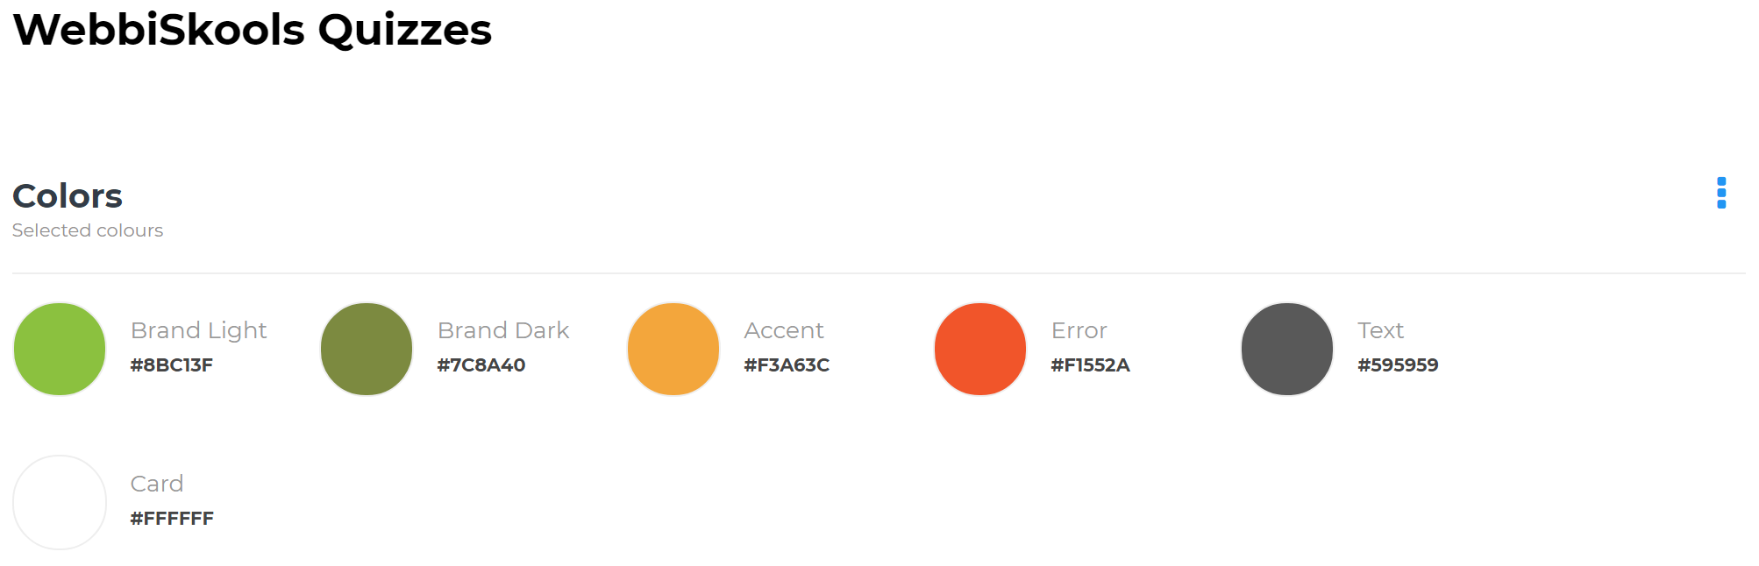

Figure : Style guide

The style guide sets a standard for the font and colours that should be used in the project. I chose these colours as they work well together and are eye-catching to the user.

## Sitemap

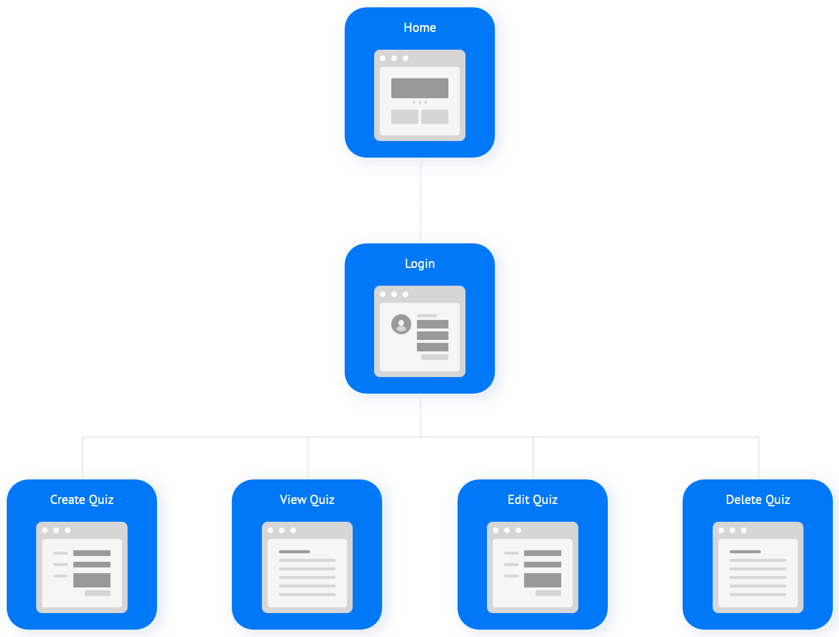

Figure : Sitemap

Users will land on the homepage and from there will be able to either create a quiz or view a quiz. Creating or viewing a quiz will require users to be signed in but users will still be able to view the title of a quiz on the homepage without being signed in. Once users are signed in they will be able to edit or delete a quiz depending on their permission level.

## Wireframes

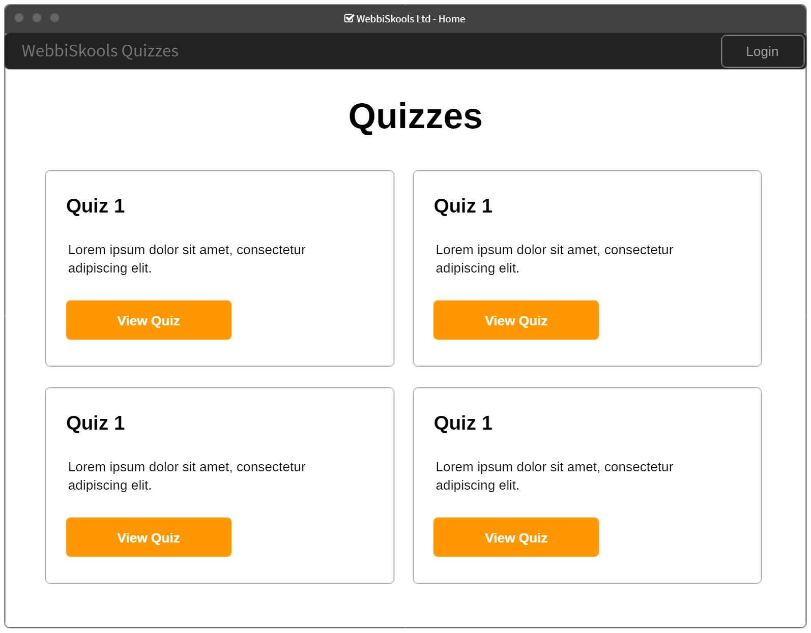

Figure : Homepage

Users will see a list of available quizzes on the homepage and the option to take each quiz. However, clicking on “Take Quiz” without being signed in will redirect the user to the login page. The same redirect will occur if a user clicks on “Create” without being signed in. The “Login” button will take users directly to the login page.

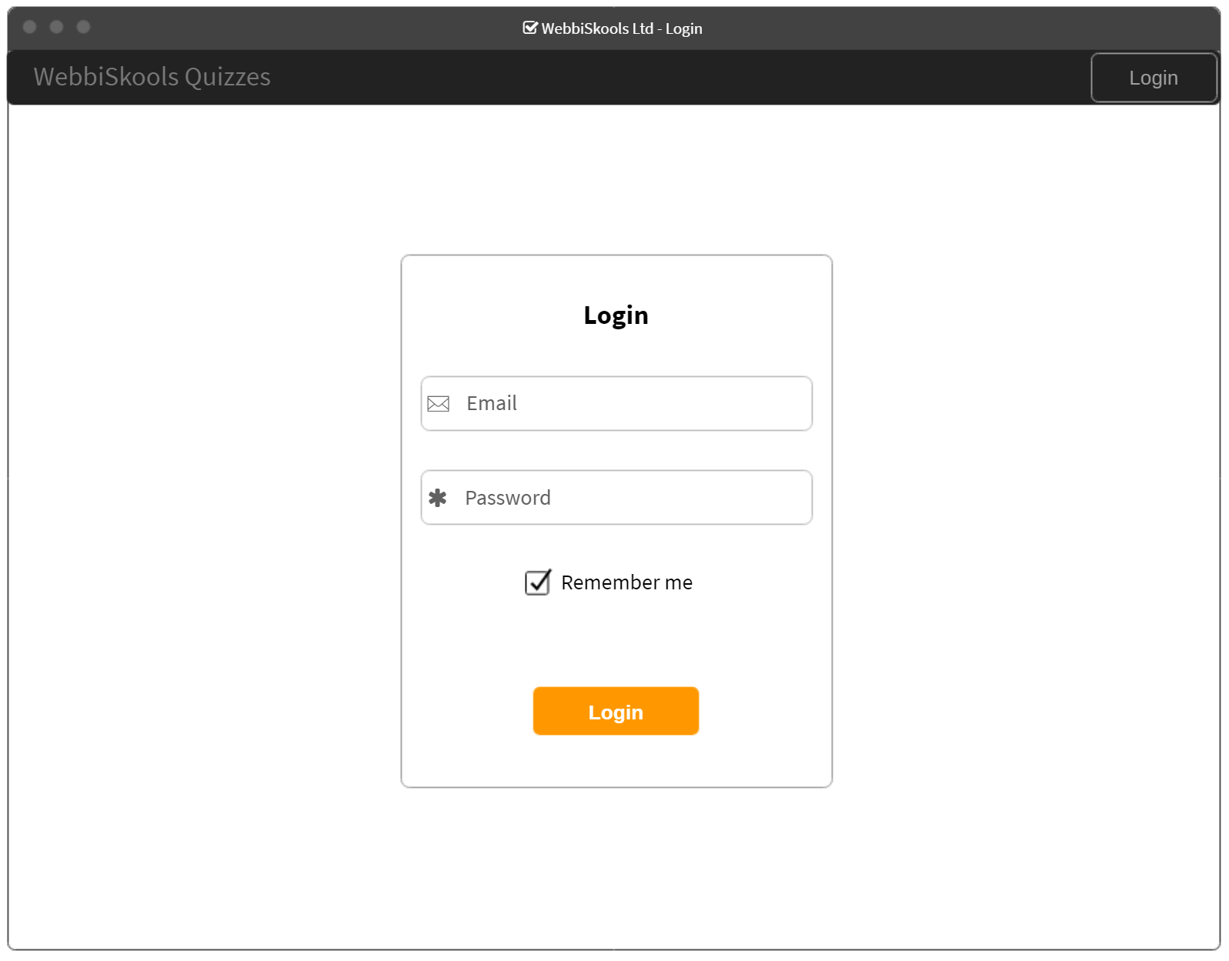

Figure : Login

The login page allows pre-defined users to log in to their account. Clicking “Login” without inputting valid data into the email and password boxes will not allow the user to log in and instead will display a validation error message. A validation message will also appear if the user inputs an incorrect email address and password. Clicking “Create” will return the user to the same login page as they will need to be signed in to create a quiz. Clicking on “WebbiSkools Quizzes” will take the user back to the homepage without being signed in.

The “Create” button is missing from this page as the user has not yet logged in. Only if a user with edit permissions will see the “Create” button in the navbar.

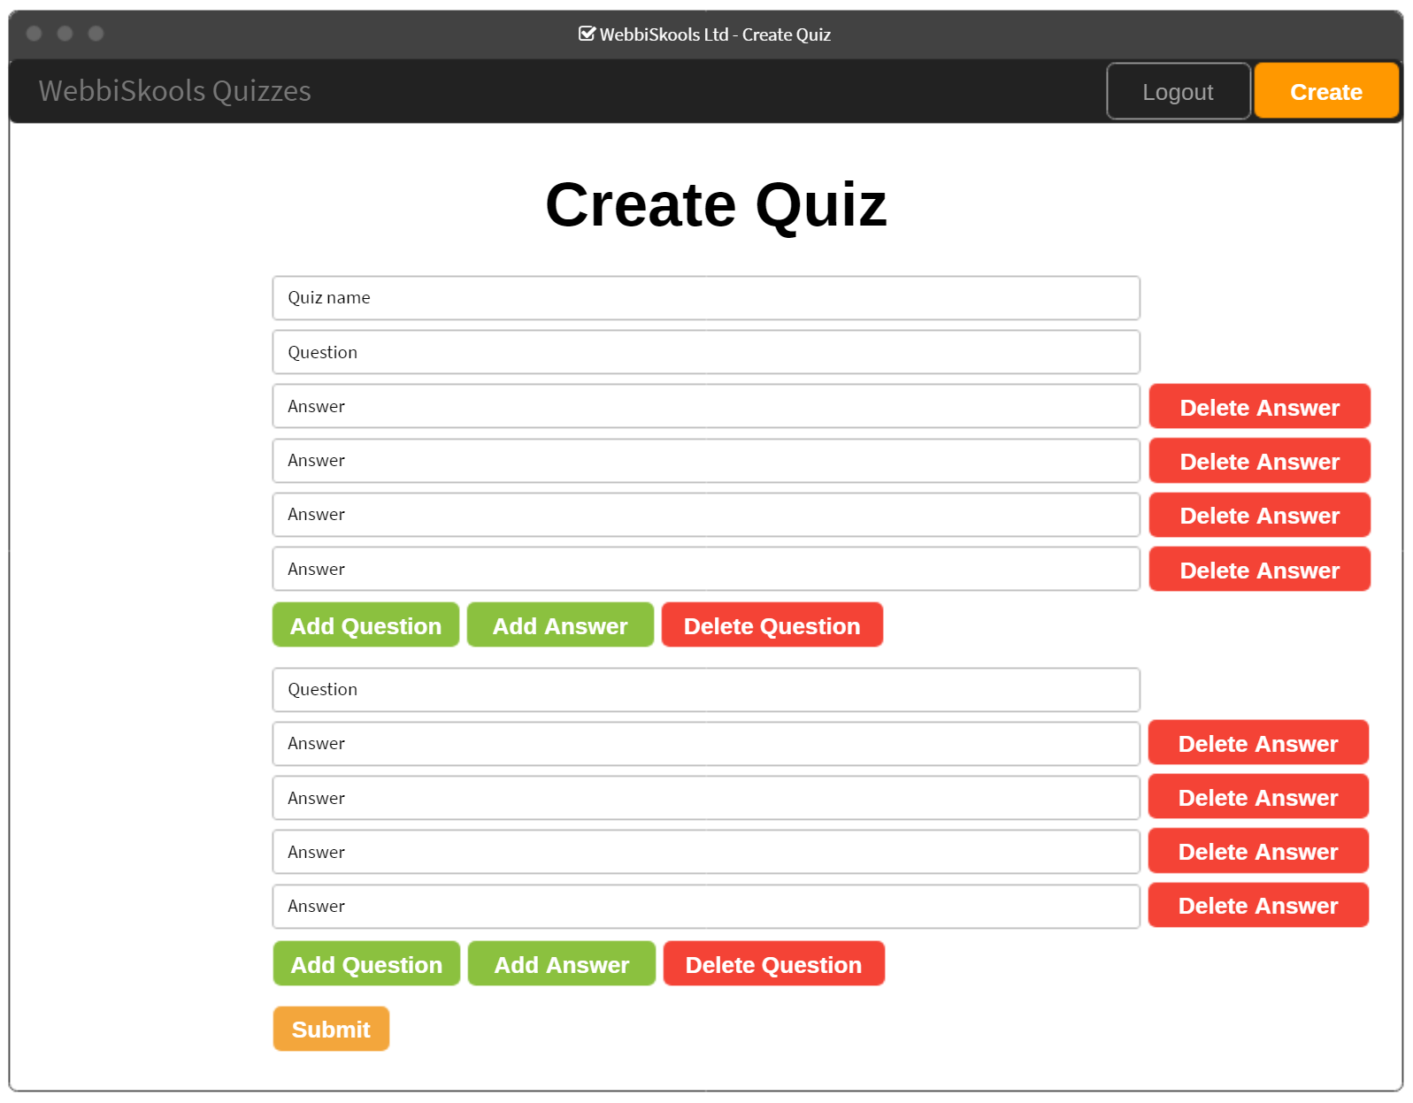

Figure : Create quiz

The create quiz page allows edit users to create a new quiz and its associated questions and possible answers. Users will only be able to provide between 3 and 5 answers for each question and any fields left blank will result in an error message being displayed. The quiz will not be saved into the database until the errors have been corrected.

If there are more than 3 answers for any question then all answers underneath that question will have a button labelled “Delete Answer” next to them. If the user clicks this button then the associated answer will be deleted. If the number of answers remaining is 3 then all “Delete Answer” buttons for that question will be removed until there are 4 or more answers for that question present.

Below each question there will be 3 buttons; “Add Question”, “Add Answer”, and “Delete Question”. When the user clicks “Add Question” a new set of input fields for a question and its associated answers will appear below the button. When the user clicks “Add Answer” a new input field for an answer will appear below the other answer inputs for the question above. When the user clicks “Delete Question” the question and its associated answers above will be removed from the page.

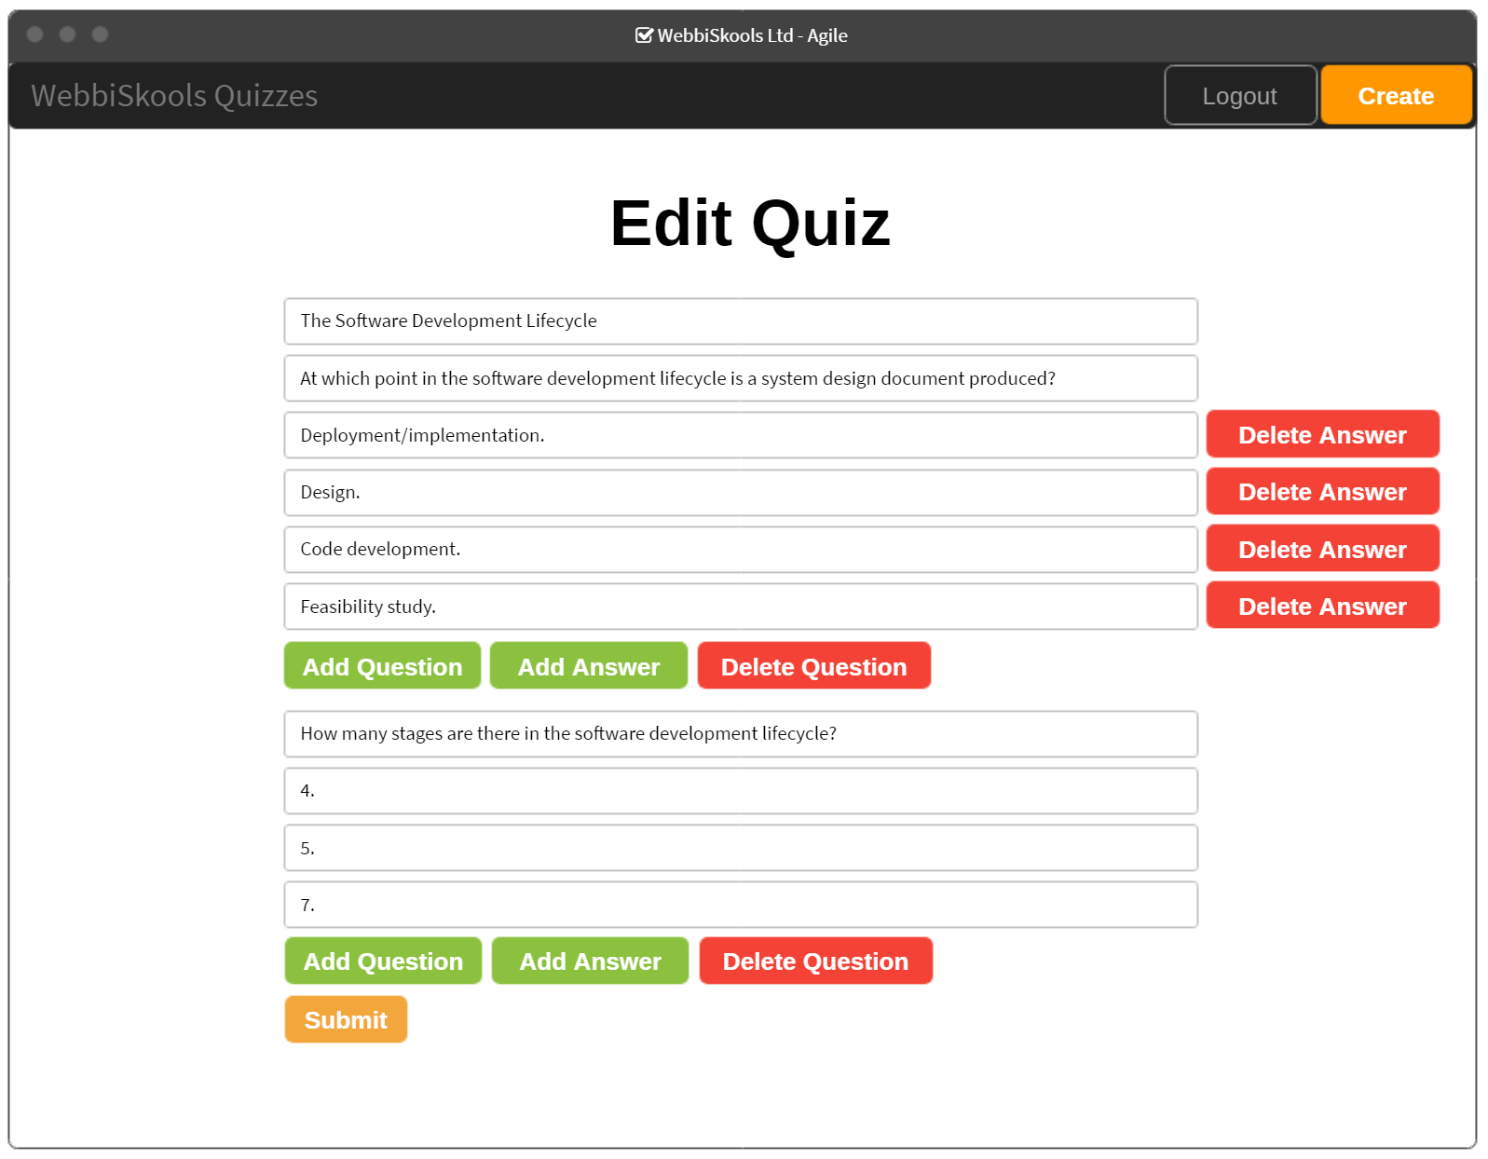

Figure : Edit quiz

The edit quiz page functions similarly to the create quiz page, except the quiz title, question texts and answer texts are already filled in. A user can add and delete questions and answers as they do on the create quiz page.

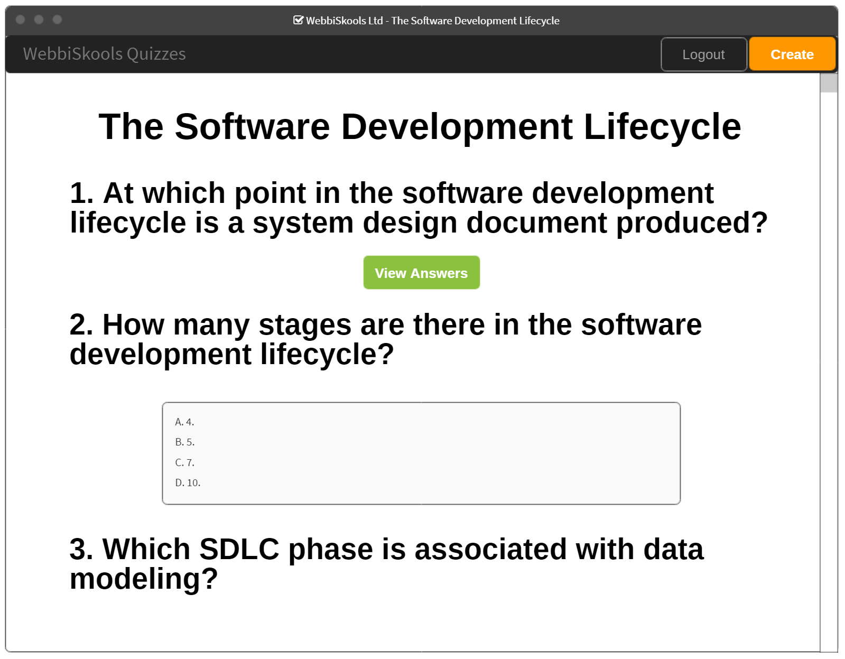

Figure : View quiz

Users will view or edit permissions will be able to view all questions in a quiz and their associated answers. Users will be able to click a button labelled “View Answers” that will expand the area underneath the question and display its possible answers. Users will be able to scroll to see all questions. if all questions do not fit on the page.

# Architectural Design

## Technical stack

* ASP.NET Core 3
* HTML5
* CSS
* JavaScript
* jQuery
* SQL Server 13
* C#

## Database

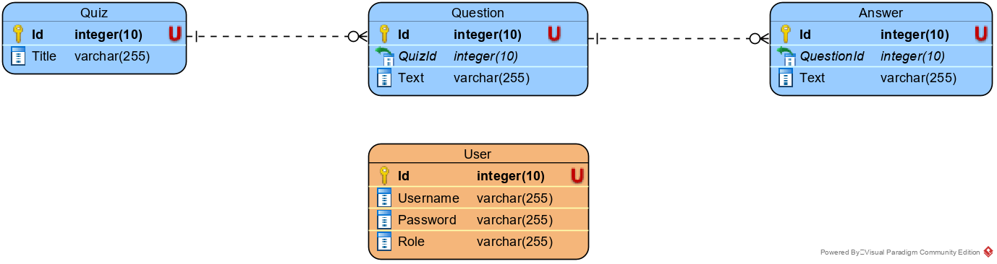

Figure : Entity relationship design

The database will be made up of four tables; quizzes, questions, answers, and users. Each answer will contain a QuestionId to tie it to a row in the Questions table. Similarly, each question will contain a QuizId to tie it to a row in the Quizzes table.

The Users table will contain a list of users, each of which will have a username, password, and role. The password field will be hashed before being stored so that the user’s password is not stored in plain text. Upon signing in, a user’s password will be hashed before being checked against the password stored in the database. If the two hashed values match then we can safely assume that the user has entered the correct password for their account.

## Classes

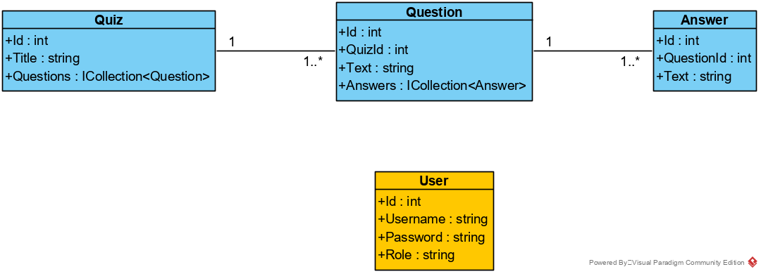

Figure : UML class diagram

Quizzes will be made up of an Id that will be generated by the database, a Title that will be provided by the user, and a collection of Questions that will also be provided by the user. Each Quiz must contain at least one Question.

A Question will contain an Id that will be generated by the database, a QuizId that will be auto-populated by the application to match each Question to its respective Quiz, a Text attribute that will be provided by the user and will contain the question to be displayed, and a collection of Answers that will also be provided by the user. Each Question must contain between three and five Answers.

An Answer will contain an Id that will be generated by the database, a QuestionId that will be auto-populated by the application to match each Answer to its respective Question, and a Text attribute that will be provided by the user and will contain the answer to be displayed.

# User Interactions

## Sequence Diagram

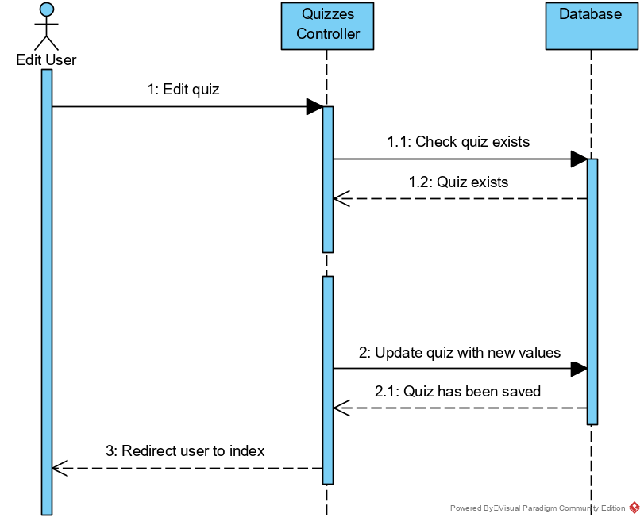

Figure : Sequence diagram

The above sequence diagram shows what happens when a user tries to update a quiz. First the amended information is passed to the Quizzes controller, the Quizzes controller then checks with the database that the quiz the user is trying to update exists. If the quiz exists, then the Quizzes controller passes the updated quiz to the database whereby it is saved. The database then lets the Quizzes controller know that the data has been saved successfully and so the Quizzes controller then sends the user back to the index page.

## Use Case

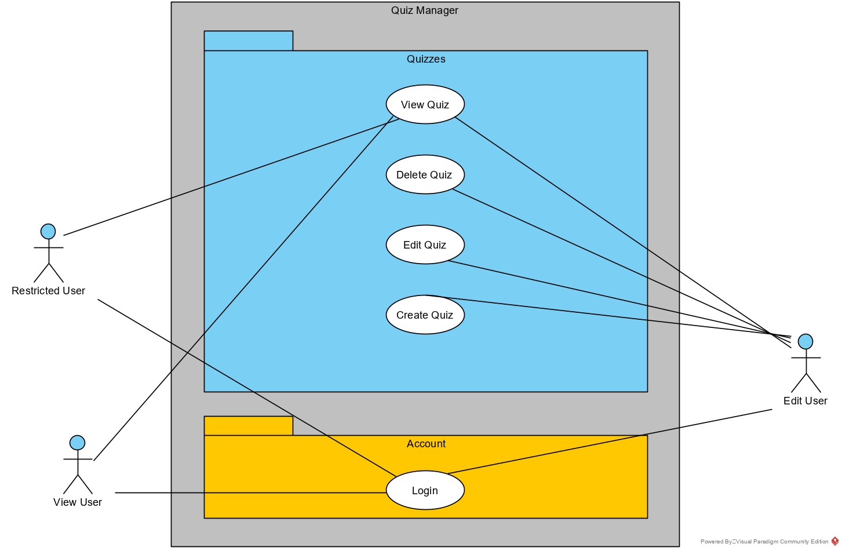

Figure : Use case diagram

All registered users can sign in and view quizzes. However, only users with Edit permissions can create, edit and delete quizzes.

## User Stories

|  |  |  |
| --- | --- | --- |
| **No.** | **User Story** | **Acceptance Criteria** |
| 1 | As an administrator,  So that I can control who can access the website,  I want to only allow registered users to sign in to the website. | 1. Only users already present in the database can sign in to the website. |
| 2 | As a user,  So that I can log in to the website,  I want to have a list of pre-configured users with which to log in. | 1. Users will be added to the database as the application starts. |
| 3 | As a user,  So that I can keep my password secure,  I want my password to be hashed before it is saved to the database. | 1. The password will be salted using the user’s username to ensure users sharing the same password will have their passwords hashed differently. |
| 4 | As an administrator,  So that I can control what certain users can do,  I want each user to be given a permission level in the database. | 1. Users will be given an attribute labelled “Role” that will contain their permission level. 2. The three permission levels available are: restricted, view, and edit. |
| 5 | As a user,  So that I can browse the website without interruption,  I want my session state to be maintained until I am logged out. | 1. The user’s username will be displayed in the navbar as long as their session is active. |
| 6 | As a user,  So that I can end my session,  I want to log out of the website. | 1. Upon logout, the user will be redirected to the login page. |
| 7 | As a user,  So that I can accurately describe my quiz,  I want to be able to give my quiz a title. | 1. When creating a quiz, the user will have an input field in which to fill out their quiz title. |
| 8 | As a user,  So that I can see how many questions there are,  I want to see questions in a numbered sequence. | 1. Questions will appear indexed with numbers (i.e. “1. What is the approximate population of London?”). |
| 9 | As a user,  So that I can display my questions,  I want to see my questions formulated as a text string. | 1. Questions will appear as a text string (i.e. “What is the approximate population of London?”). |
| 10 | As a user,  So that I can keep the number of possible answers concise,  I want to only be able to have between 3 and 5 answers for each question. | 1. A user cannot add more than 5 answers to a question when creating a quiz. 2. A user cannot remove any more answers once a question has 3 answers when creating a quiz. 3. A user cannot add more than 5 answers to a question when editing a quiz. 4. A user cannot remove any more answers once a question has 3 answers when editing a quiz. 5. If a user is able to bypass the front end logic and submit a quiz with one or more questions containing more than 5 answers or less than 3 answers when creating or editing a quiz, the user will be returned to the create/edit page without their changes being saved. An error message will also be displayed on the page. |
| 11 | As a user,  So that I can display the answers to my question nicely,  I want to see my answers indexed with an uppercase character. | 1. Answers will be displayed prefixed with an uppercase character on the display page (i.e. “A. ‘250 thousand’”). |
| 12 | As a restricted user,  So that I can view a quiz,  I want to be able to select a quiz and view all the questions within that quiz. | 1. When a restricted user views a quiz, they should only be able to see the questions within that quiz and not any of the answers. |
| 13 | As a user,  So that I can easily view a quiz,  I want to be able to scroll up and down to see all the questions within a quiz. | 1. A user should see a scrollbar when the quiz does not fit on one page. |
| 14 | As a view user,  So that I can see the answers to a question,  I want to be able to select a question and see its associated answers. | 1. Each question on the page will have a button called “See Answers”. 2. When the user clicks on that button, the question will expand to show all available answers. 3. This button will not appear for restricted users. 4. This functionality will be the same for edit users. |
| 15 | As an edit user,  So that I can add quizzes,  I want to be able to create a quiz. | 1. A button labelled “Create” will appear in the navbar for edit users when they are signed in. 2. This button will not be available to restricted or view users. 3. If a restricted or view user tries to navigate to the create page, they will be shown an access denied page instead. |
| 16 | As an edit user,  So that I can keep quizzes up-to-date,  I want to be able to delete a quiz. | 1. A button labelled “Delete” will appear above every quiz on the homepage. 2. This button will only be available to edit users. Restricted and view users will not be able to see this button. 3. If a restricted or view user navigates to the delete page, they will be shown an access denied page instead. |
| 17 | As an edit user,  So that I can keep quizzes up-to-date,  I want to be able to add questions at any point in the sequence of questions for a quiz. | 1. When an edit user edits a quiz, there will be a button labelled “Add Question” in between each question and again at the end of the list of questions. 2. Upon clicking the button, the user will be provided will a new set of input fields with which to specify a question and its possible answers. 3. The inputs will be added with 3 inputs for answers. 4. The new question will contain an “Add Answer” button that will function as it normally does. 5. Upon submitting the form, the questions will be renumbered in order to keep their order. |
| 18 | As an edit user,  So that I can keep quizzes up-to-date,  I want to be able to edit the text of any question. | 1. When editing a quiz, the questions will appear as input fields with their current value already populated. The user can then change this value and resubmit the quiz. 2. The quiz will be updated in the database to include the change to the question text. |
| 19 | As an edit user,  So that I can keep quizzes up-to-date,  I want to be able to edit the text of any answer. | 1. When editing a quiz, the answers will appear as input fields with their current value already populated. The user can then change this value and resubmit the quiz. 2. The quiz will be updated in the database to include the change to the answer text. |